Mobile Web Application

For Day of Rental and Reservation Utilities

The following sections describe pages the renter flows through to rent and retrieve the contents from their locker or reserve lockers for future use. Reservations are limited to full towers.

Start Page
These pages appears when the mobile web application is first navigated to by the renter. If the renter’s GPS is on and location shared then the web app will identify the venue where the renter is located. Otherwise the renter must scan a Tiburon QR code for the venue or enter the venue name.
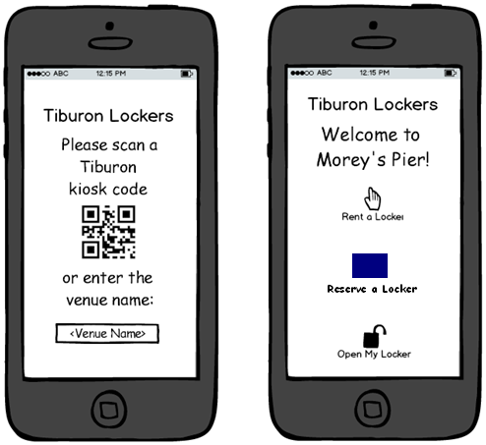
Figure 1: Mobile Start Page

Event: | Displaying the Mobile Start Page
Description: | Occurs when a renter navigates to the mobile web page url via a Tablet or mobile device browser.
Post-Conditions: | The application has identified the renter’s location via GPS or the renter has scanned a QR code or filled in the venue name and it is validated.
Success Path: |  | The application has identified the location by GPS.
 |  | The renter scans a Tiburon QR code.
 |  | The Renter selects the text area.
 |  | The system displays the local keyboard
 |  | The Renter inputs the venue name and selects “Done” on keyboard
 |  | The system validates the text area
 |  | The Renter selects one of the three buttons “Rent a Locker” or “Open My Locker”.
Alternate Path: | The Renter selects the “Rent a Locker” button.
 |  | The Renter is sent to the “Find A Locker Page”
Alternate Path: | The Renter selects the “Reserve a Locker” button.
 |  | The Renter is sent to the “Reserve Compartment Type Page”
Alternate Path: | The Renter selects the “Open My Locker” button.
 |  | The Renter is sent to the “Open My Locker Page”
Assumptions: | A Tiburon QR code is displayed on the physical Kiosk.

Find a Locker Page
This page appears to gather information from the renter necessary for finding lockers or ChargeDaddy units to be displayed on a map.
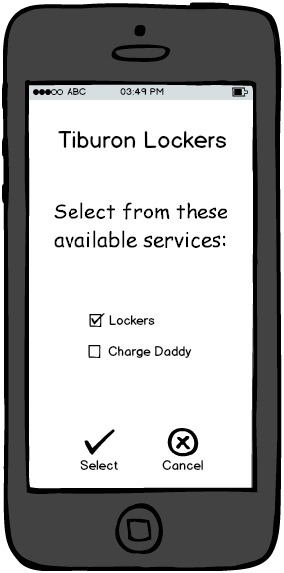
Figure 2: Mobile Find a Locker page
Event: | Finding a Locker Location
Description: | Occurs when a renter navigates to the mobile web page URL via a Tablet or mobile device browser.
Pre-Conditions: | The renter’s venue location has been previously identified.
Success Path: |  | The system activates the appropriate check box options.
 |  | The Renter selects the desired checkboxes.
 |  | The Renter selects the “See Locker Locations” button taking them to the “Select Kiosk Page”
Alternate Path: | Renter decides to go back to the home page.
 |  | The Renter selects the “Back” button and is sent to the “Start Page”
Notes: | This full list of venues and locations are maintained in the Central Admin site and are NOT displayed to the user.

Select Kiosk Page
This page appears to allow the renter to select a Locker or ChargeDaddy kiosk on the map located nearby to where they are using their phone’s GPS unit if present.
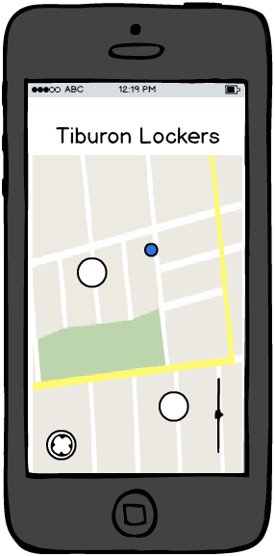
Figure 3: Mobile Select Kiosk page
Event: | Renter Selects a specific Kiosk / Locker Location at a Venue
Description: | Occurs when a renter navigates to the mobile web page URL via a Tablet or mobile device browser. Allows the renter to select the specific kiosk at the Venue (represented as a white circle here).
Pre-Conditions: | Renter utilizes the Tablet or mobile device browser. Mobile device contains GPS Capabilities.
Success Path: |  | The Renter selects a Kiosk.
 |  | The Renter is sent to the “Select Compartment Type Page”
 |  | Renter decides to go back to the home page.
Alternate Path: |  | The Renter selects the “Back” button and is sent to the “Find a Locker Page”
Assumptions: | The Renter utilizes the mobile devices built in GPS capabilities already integrated into the mobile browser to find the Renters Location ( blue dot in picture).  The renter can zoom and pan the map ( Zoom bar in the picture above).

Select Compartment Type Page
This page appears to allow the renter to select which type of compartment they wish to rent.
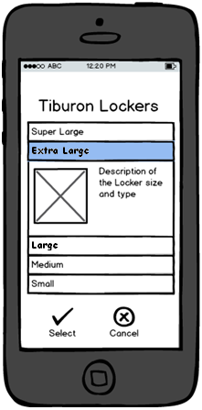
Figure 4: Mobile Select Compartment Type page
Event: | Renter Selects a Compartment Type
Description: | Renter selects a compartment type that is available to rent.
Post-Conditions: | Renter must select a compartment type option in order to proceed.
Success Path: |  | The Renter selects a Compartment Type.
 |  | The Accordion control opens and shows the Description.
 |  | The Renter decides to proceed and selects the “Select” button
 |  | If a compartment of the type selected is not available, the renter is notified and requested to make a different selection.
 |  | The system displays the “Select Rental Type Page”.
Alternate Path: | Renter decides to go back to the home page.
 |  | The Renter selects the “Cancel” button and is sent to the “Select Kiosk Page”.
Assumptions: | The Web Application maintains the state of rental availability within a predefined interval of time.  The Tiburon Administrator has configured the Locker Location to participate with mobile transactions.

Select Rental Type Page
This page appears to allow the renter to select which type of rental they wish to purchase.
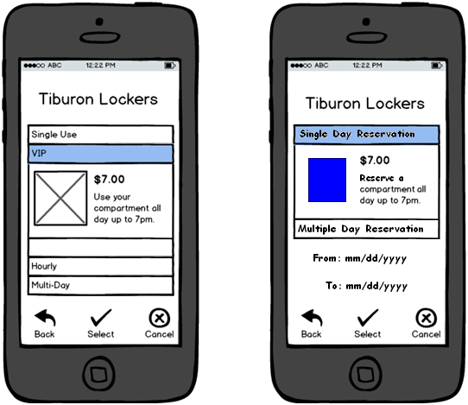
Figure 5: Mobile Select Rental Type page

Event: | Renter Selects a Rental Type
Description: | Renter selects a rental type that is available for the selected Locker Size.
Success Path: |  | The Renter selects a Rental Type.
 |  | The Accordion control opens and shows the Price and Description.
 |  | The Renter decides to proceed and selects the “Select” button and is sent to the “Credit Card Info Page”.
Alternate Path: | Renter decides to go back to the home page.
 |  | The Renter selects the “Cancel” button and is sent to the “Select Compartment Type Page”.
Exception Path: | Compartment Type is no longer available. The renter must select the “Back” button.
Assumptions: | The Web Application maintains the state of rental availability within a predefined interval of time.  The Tiburon Administrator has configured the Locker Location to participate with mobile transactions.
Notes: | It is possible that the renter may wait too long to make a choice.

Credit Card Info Page
This page appears to allow the renter to specify the credit card information necessary to purchase a locker or ChargeDaddy compartment.
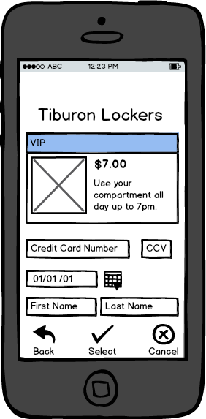
Figure 6: Mobile Credit Card Info page
Event: | Renter Submits Credit Card Information
Description: | Renter has selected a Compartment and Rental type.
Pre-Conditions: | The Application verifies that both the Rental and Compartment Type is still currently available at the time the page loads.

Rental Confirmation Page
This page appears to confirm a successful rental to the renter.

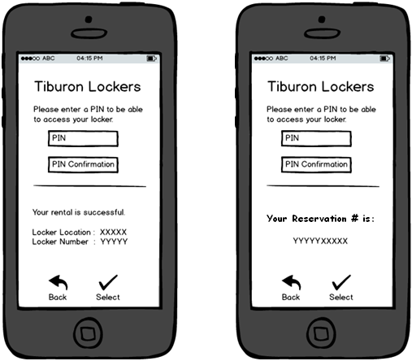
Figure 7: Mobile Rental Confirmation page

Event: | Renter Confirmation
Description: | Renter has completed all steps to secure a compartment but must now select a PIN to access the compartment.
Pre-Conditions: | This page prompts for a PIN even if a Kiosk is configured to NOT utilize a PIN. The “Select” and “Back” button is inactive.
Success Path: |  | The Renter inputs the PIN and PIN Confirmation code.” .
 |  | The system validates that the PIN’s are identical and activates the “Select” button
 |  | The Renter decides to keep the PIN and selects “Select” which sends a message to the Administrative Website to make the credit card transaction, reserve the compartment, and store the PIN.
 |  | The system displays the selected kiosk on an interactive map.
Alternate Path: | Renter decides to go back a step.
 |  | Action will not be allowed and the Back button will stay inactive.
Exception Path: | It is possible that the renter may wait too long, In this case the Renter must configure a pin through the Venue Administrator directly on the Kiosk.
Assumptions: | A 4 digit code is enforced.  The Tiburon Administrator has configured the Locker Location to participate with mobile transactions.


Lookup Rental Page
This page appears to allow the renter to enter information necessary to lookup and assign a locker or compartment that was previously rented.

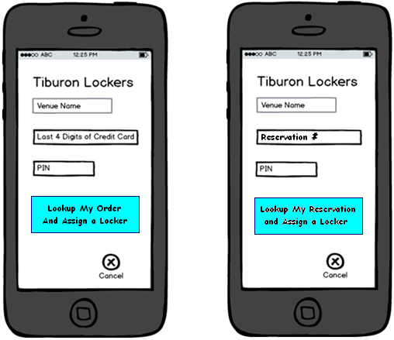
Figure 8: Mobile Lookup Rental page

Event: | Lookup Locker
Description: | Renter has completed all steps to secure a compartment and is now ready to Open a Locker.
Success Path: |  | The Renter inputs the Credit Card number and PIN code.”
 |  | The system validates the information is numeric and the right length and then activates the “Open My Locker” button.
 |  | The Renter selects the “Lookup” button which sends them to the “Open My Locker Page”
Alternate Path: | Renter decides to Cancel.
 |  | The Renter selects the “Cancel” button and is sent to the “Start Page”.
Exception Path: | If information is not correct or connectivity is down, a renter friendly notice is displayed to the Renter.
Assumptions: | A 4 digit code is enforced. The Tiburon Administrator has configured the Locker Location to participate with mobile transactions.  Renters who have used the Kiosk to Rent can use the site to open a Locker.

Open My Locker Page
This page appears to allow the renter to unlock their locker.
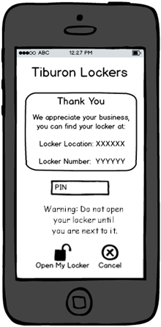

Figure 9: Open Locker page
Event: | Mobile Open Locker confirmation page
Description: | Identifies the locker and allows the user to unlock their locker
Pre-Conditions: | The Kiosk standard message is configured locally for display here on the mobile site.
Success Path: |  | Renter enters their PIN and presses “Open My Locker”.

